**Title (Times New Roman, font size 18)**

**Presenting Author1**, Co-Authors2,* (Times New

Roman, font size 12)

*Department, Organisation, Address, City, Country (Italic, Times New Roman, font size 11)*

*Corresponding Author E-mail: (Times New Roman, font size 10)

You are invited to submit your abstract (Maximum one A4 page). The topics of the Conference includes, Fundamentals, Processing and Chemometrics, Instrumentation, novel approach and multimodal, Cultural heritage, Industry and Energy, Biology, Health and Agronomy, Environmental and geological sciences, Extreme Environments and nuclear applications, Others… For online technical program consistency, **this Abstract Template must be used for abstract submission**. Times New Roman, font size 11 for the text of abstract.

**Abstracts of a maximum one A4 page, including any illustration, must be submitted online before October 17, 2025. Authors will be notified of abstract acceptance by November 15, 2025.** Each paper accepted for oral or poster presentation must be accompanied with registration by January 20, 2025.

**Keywords:** Keyword1; Keyword2; Keyword3; Keyword4; (Maximum 4). (Times New Roman, font size 11)

References must follow the following format [1].

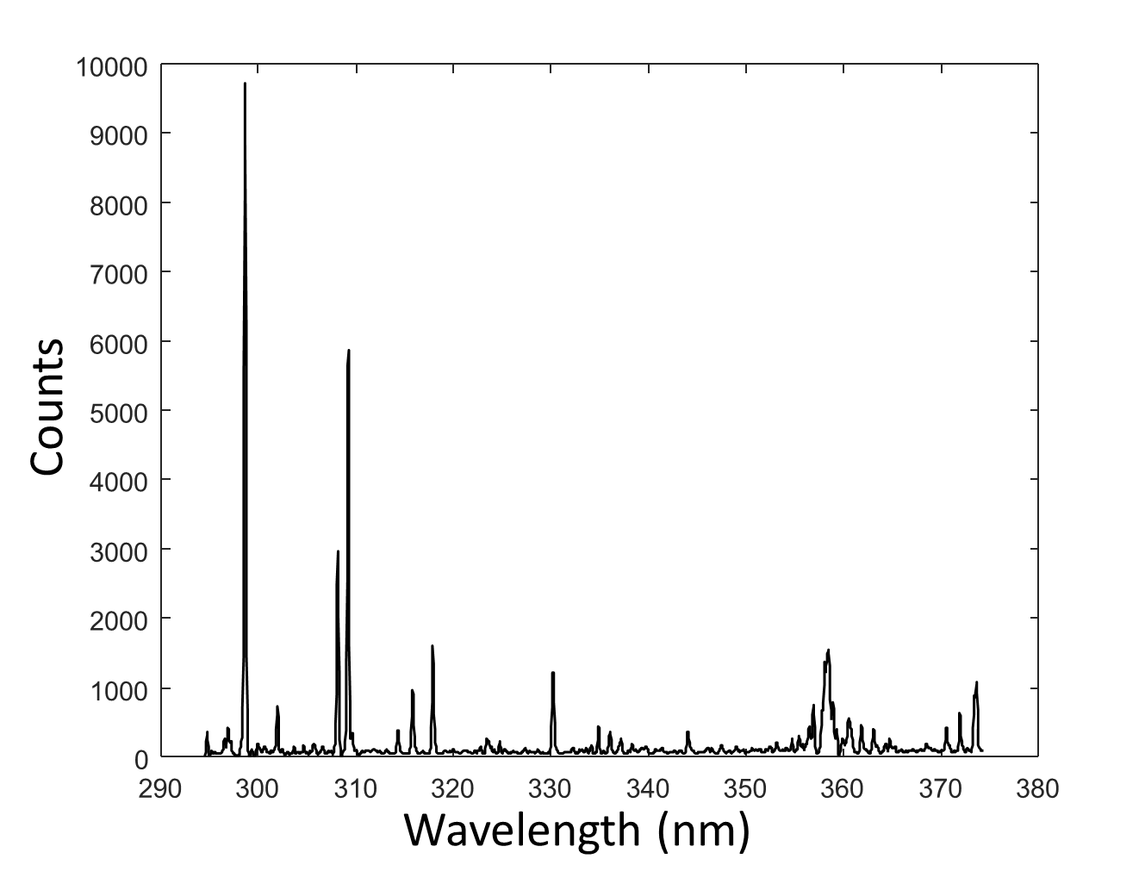

**Fig. 1** An illustration is always encouraged (legend:Times New Roman, font size 10, centered)

**REFERENCES**

[1] L. Dupont, M. Dupond, *Vive la LIBS! A French touch to spectroscopy*, Analytica Chimica Acta, 1000 (2019) 115–125. <https://doi.org/senlis.libs/j.aca.2025.01.26>.